**Session 1 (unit-1): Flow control and Functions**

1. **WAP: to find the largest of three numbers and print the largest number**.

#include<iostream>

using namespace std;

int main()

{

int a,b,c;

cout<<"Enter the 3 number ";

cin>>a>>b>>c;

if((a>b)&&(a>c))

{

cout<<"The Largest Number is :"<<a;

}

else if((b>a)&&(b>c))

{

cout<<"The Largest Number is :"<<b;

}

else if((c>a)&&(c>b))

{

cout<<"The Largest Number is :"<<c;

}

}

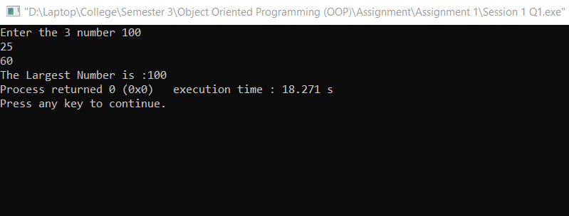

1. **WAP to find the factorial of a number using for loop.**

#include<iostream>

using namespace std;

int main()

{

int n;

int factorial = 1 ;

cout<<"Enter the number: ";

cin>>n;

for(int i=1;i<=n;i++)

{

factorial=factorial*i;

}

cout<<"Factorial of "<<n<<" is "<<factorial;

}

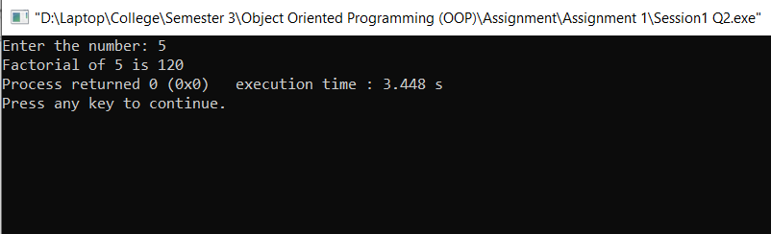

1. **WAP to generate the random numbers in any specific range specified by the user. Ensure that for each run the numbers generated even in the same range are random and not same**

#include <iostream>

#include <ctime>

#include <cstdlib>

using namespace std;

int main()

{

int n;

srand(time(0)); // Initialize random number generator.

cout<<"Enter the Number ";

cin>>n;

cout<<"Random numbers generated between 1 and "<<n<<" is : "<<endl;

for(int i=0;i<n;i++)

cout << (rand() % n) + 1<<" ";

return 0;

}

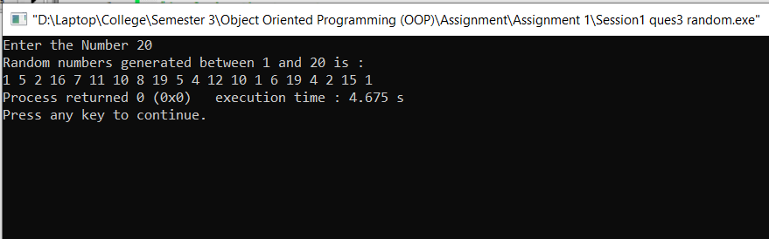

1. **Define a function to calculate power of a number raised to other i.e. a^b using recursion where the numbers 'a' and 'b' are to be entered by the user**

#include <iostream>

using namespace std;

int calculatePower(int, int);

int main()

{

int base, powerRaised, result;

cout << "Enter base number: ";

cin >> base;

cout << "Enter power number(positive integer): ";

cin >> powerRaised;

result = calculatePower(base, powerRaised);

cout << base << "^" << powerRaised << " = " << result;

return 0;

}

int calculatePower(int base, int powerRaised)

{

if (powerRaised != 0)

return (base*calculatePower(base, powerRaised-1));

else

return 1;

}

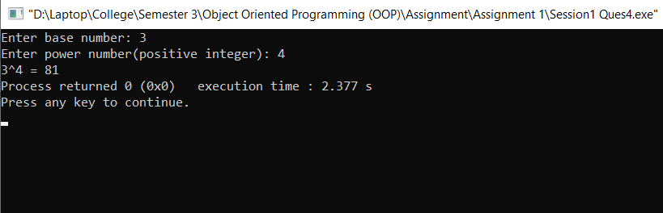

1. **WAP to accept the marks of a student in three subjects and calculate its average using a function.**

#include<iostream>

#include<stdio.h>

using namespace std;

int main()

{

int i;

char name[25];

int marks[3];

int sum =0;

cout<<"Enter the Name of Student ";

gets(name);

cout<<"Enter the marks of 3 subject ";

for(i=0;i<3;i++)

{

cin>>marks[i];

sum = sum+marks[i];

}

int average=(sum/3);

cout<<"Name :"<<name<<endl;

for(i=0;i<3;i++)

{

cout<<"Marks Of 3 Subject :"<<marks[i]<<endl;

}

cout<<"Average :"<<average;

}

